 | YEAR 12 MATHEMATICS SPECIALIST  SEMESTER TWO 2017  TEST 3: Applications of Calculus

Name: _______________________

Monday 15th August Time: 50 minutes Mark /45
Section 1 – Calculator free 25 marks

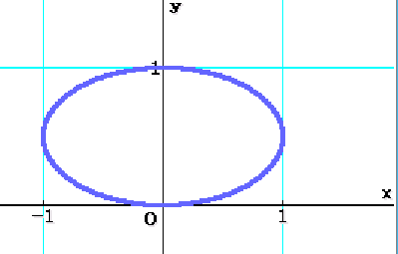
[5 marks – 4 and 1]
The curve defined by the equations for generates the ellipse shown.
- Show that

- What is the slope of this curve at the point where ?

[4 marks]
If and , determine the rate of change of x when

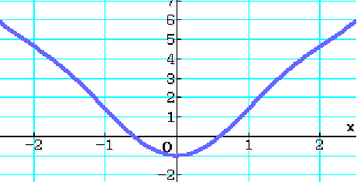
[4 marks – 2 and 2]
is an even function, symmetric about the y-axis, as shown.
- Show clearly that

- Evaluate and B so that

[5 marks – 3 and 2]
- Calculate

- Describe, terms of the curves and , the quantity represented by your calculation in part (a).

[7 marks – 3, 1 and 3]
Determine each of the integrals given:
- where

- Use the substitution to evaluate in simplest exact form.

Section 2 – Calculator assumed 20 marks Name:

[9 marks – 3, 2 and 4]
The equation of a curve in the plane is given by
- Derive an expression, in terms of x and y, for . Check on ClassPad.

- Find the equation of the tangent at the point

- At which points on the curve is the tangent parallel to the y axis?

[6 marks – 3, 2 and 1]
Compare the volumes generated when the ellipse with equation is revolved about the x axis and then the y axis.
Briefly explain why the larger value is the greater.

[5 marks]

David is flying a kite, which maintains a constant height of 26 m.

The string from David’s hand, 1 m above the ground, to the kite is taut (i.e. forms a straight line) and he is releasing this string at a rate of 1.2 m per second.

Describe the motion of the kite when the length of the string is 65 m.

